**P8 – Compare RISC Chip and CISC Chip**

**Introduction**

In this report, I will be naming the advantage, disadvantage and explaining what each of the chips are. Then I will be comparing reduced instruction set computer (RISC) and complex instruction set computer (CISC) chips.

**RISC**

RISC stands for reduced instruction set computer. This is a CPU design that executes a fewer cycles per second, so that I can operate in a greater speed. It has more transistors to execute each instruction much faster. A transistor is used to switch electronic signals within a circuit. The capacitor only stores charged (0) and discharged (1). This chip can be used in any computer, and an example of where it is used is the K computer. This is one of the fastest in 2011.

**Advantage**

* 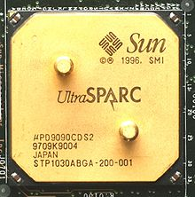Speed of this is high
* It is simple, compared to CISC
* Easy to design
* Less complicated

**Disadvantage**

* Quality
* More memory required
* Fewer instructions set

**CISC**

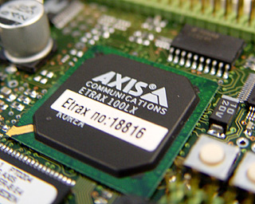CISC stands for complex instruction set computer. This chip is a CPU design that uses a complex instruction base. This is different to RISC, and it executes more than one job in one instruction. For example, load from memory, arithmetic operation, and memory store can be all done by this chip in one go. An example of where CISC is used is in the Intel’s Pentium.

**Advantage**

* Less expensive
* Efficient
* Flexible – Gets more jobs complete in one instruction
* Lower memory use due to lower use of instruction

**Disadvantage**

* Not of the instructions, in one go, can be executed with this chip
* Complex design

**Comparison – CISC vs. RISC**

* The path that CISC has to take is very long, due to the jobs it has to execute. However, RISC executes the only instruction straight away.
* RISC has a low cycle per second, but CISC has a high cycle per second
* RISC has a limited number of instructions, such as printers and CISC has a number of instructions that it can execute
* RISC needs help from other chips, but CISC does it all itself
* CISC is slow, because of a number of jobs it needs to execute, but RISC is faster as it only does one job per instruction
* CISC focuses on hardware, but RISC focuses on software

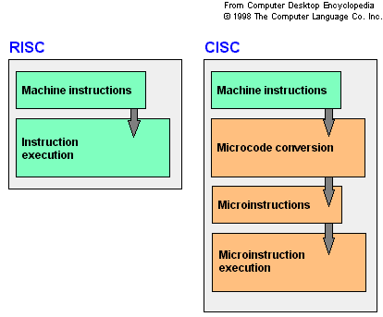

**Reference**

* <http://en.wikipedia.org/wiki/Reduced_instruction_set_computing>
* <http://en.wikipedia.org/wiki/Complex_instruction_set_computing>